

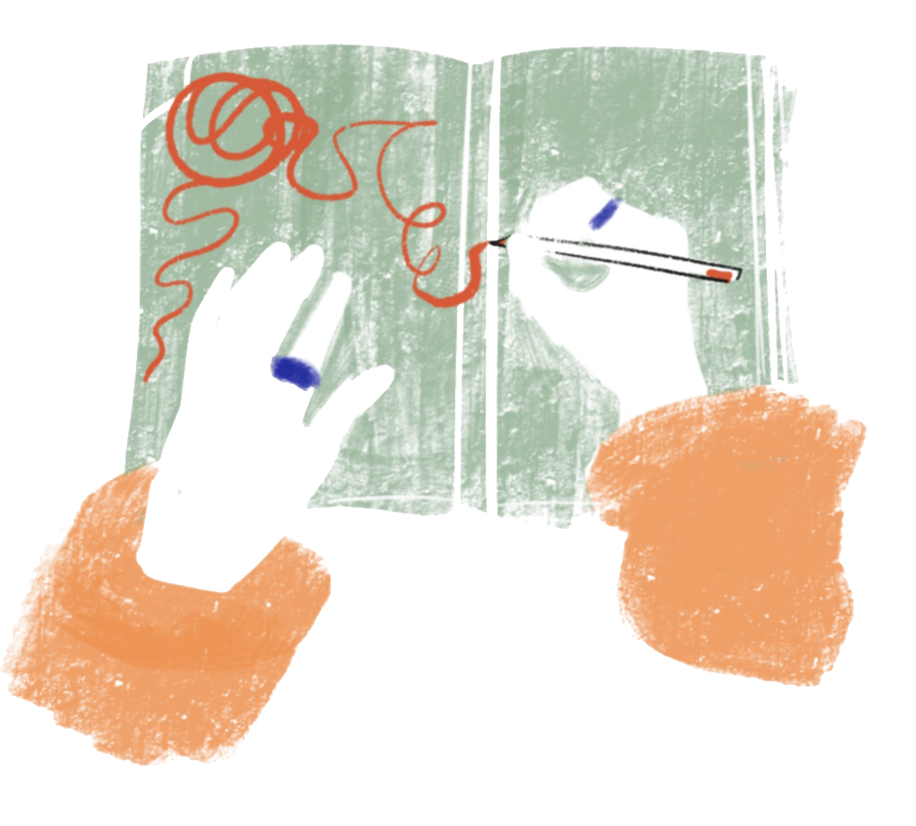
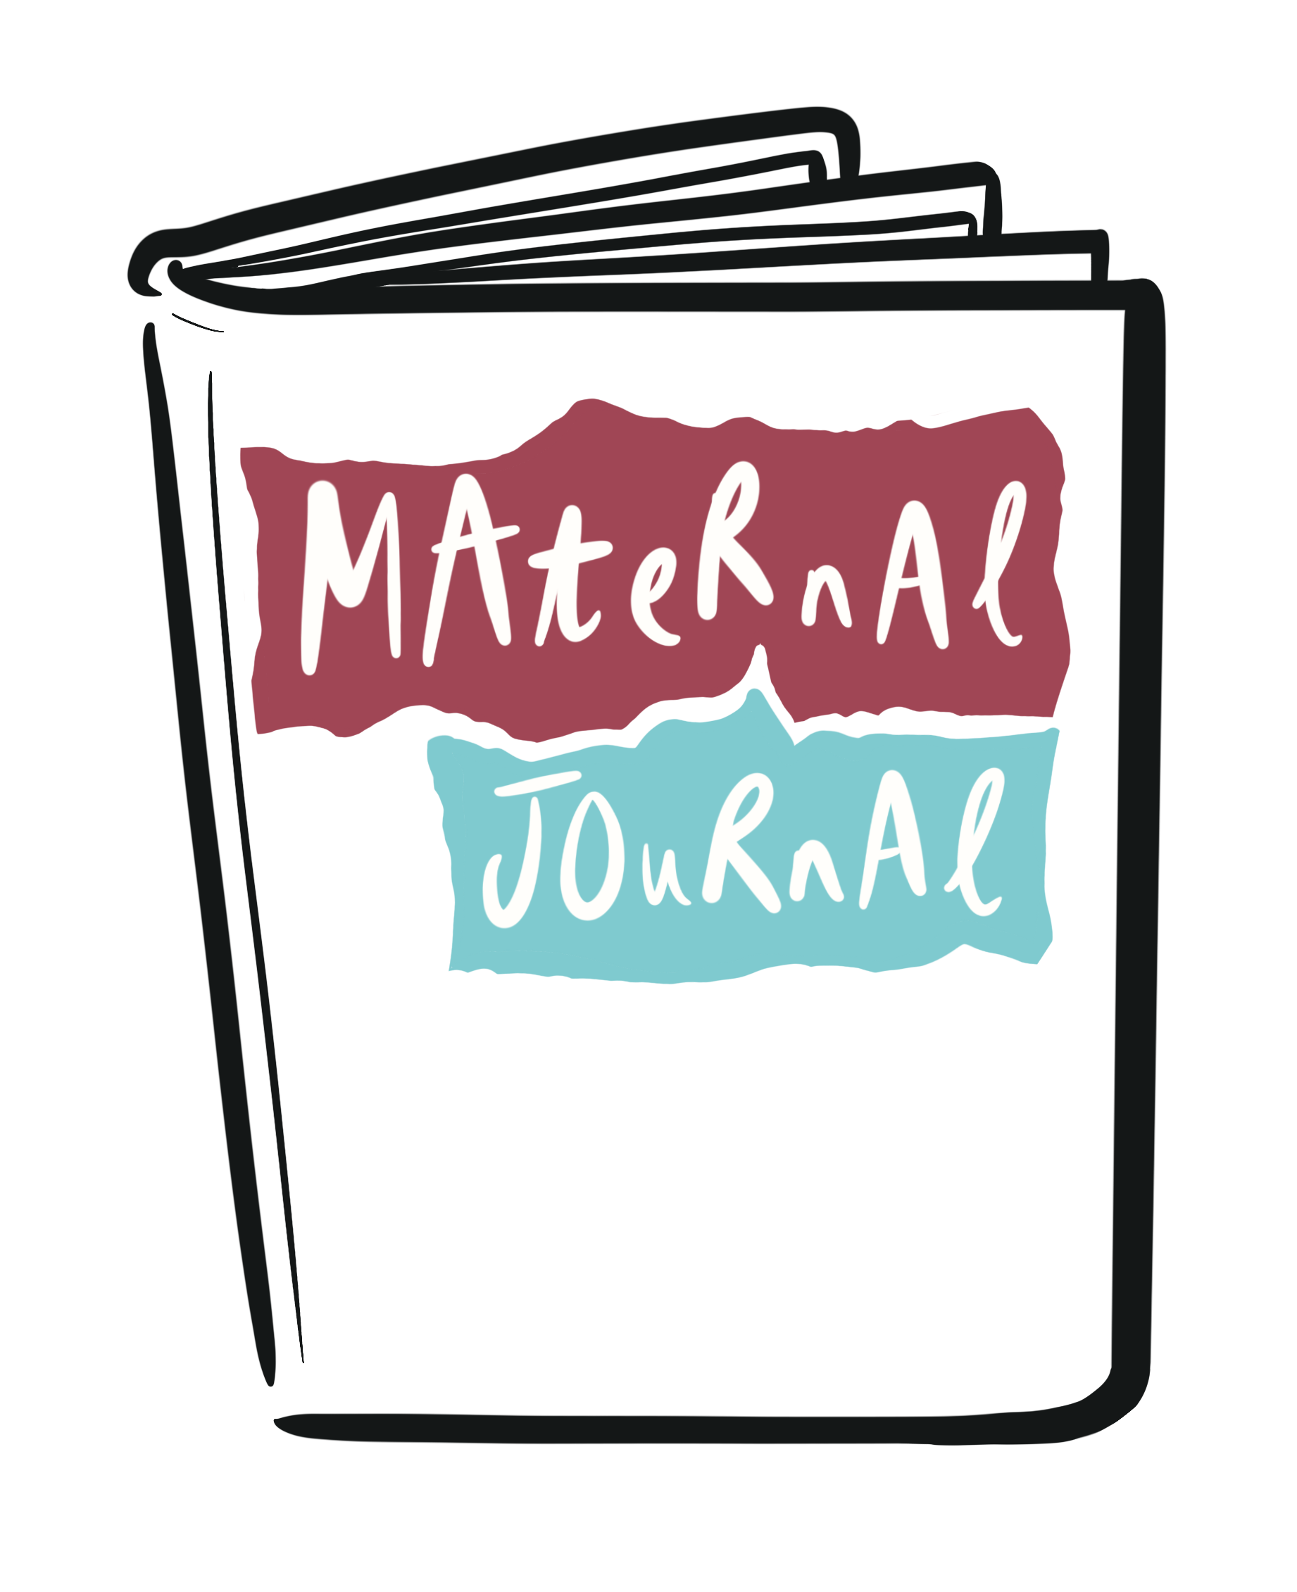



Maternal Journal provides a positive outlet for some of the new feelings and challenges you might experience, both physically and emotionally in pregnancy and new parenthood. Through a series of creative workshops, we will explore the history and practice of journaling to promote positive mental health and well-being. To sign up, please get in touch using the details below.
www.maternaljournal.org
#maternaljournal

DATES:
LOCATION:
CONTACT:
JOIN US:

Join us at a local
Maternal Journal group

Twitter: @maternaljrnl
Insta: @maternaljrnl
Facebook: @maternaljournal

